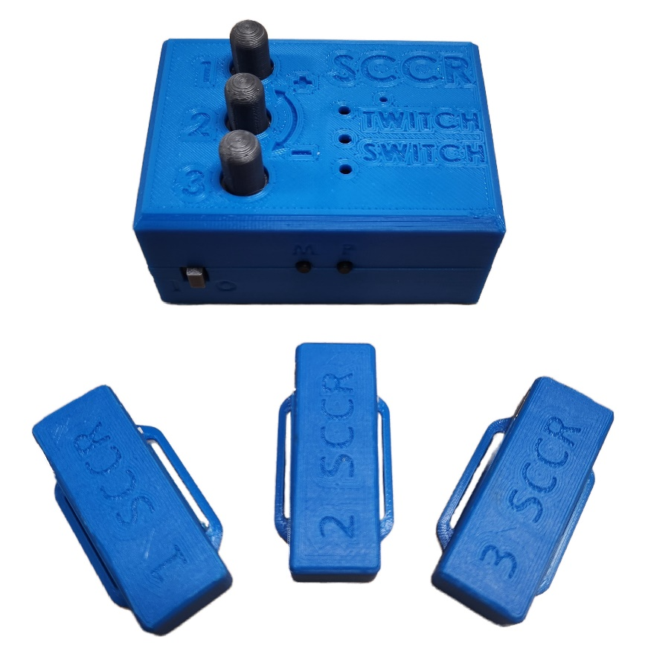

Twitch Switch User Guide

V3.0 – March 2024

Contents

Disclaimer/Assumption of Risk 3

Introduction 4

Features 4

Controller Features 5

Sensor Features 6

Usage 7

Compatibility 7

Sensor Placement 7

Setup Guide 8

Charging Instructions 9

Manual Calibration 10

Controlling Switch Adapted Devices 10

Connecting to Computer, Tablet, or Smart Phone 12

Connecting to Host Device Using Bluetooth 12

Connecting to Host Device Through USB 12

Operating Modes 13

Overview 13

Mouse Mode 13

Tablet Mode 13

Keyboard Mode 14

Profiles 14

Troubleshooting 15

Troubleshooting Guide 15

Performing a Factory Reset 15

Cleaning and Maintenance 15

Specifications 16

# Disclaimer/Assumption of Risk

**The Twitch Switch device is not to be used in life support or life safety applications. Such use is entirely at the User’s risk, and the User agrees to defend, indemnify and hold harmless the Stan Cassidy Center for Rehabilitation from any and all damages, claims, suits, or expenses resulting from such use.**

# Introduction

The Twitch Switch device is designed to address the needs of people with very limited movement capabilities. It operates by using wireless sensors placed on the body to detect small movements and relaying them to a controller that operates your switch-adapted devices or a personal computer. You can use just one, two, or all three sensors at the same time to match your needs.

The following is an easy setup guide to get you started. You will need a micro-USB cable, a mini-USB cable, and up to three audio cables, depending on how you wish to use your device.

You will also need to provide materials to secure your sensors in place; see suggested materials on page 7.

# Features

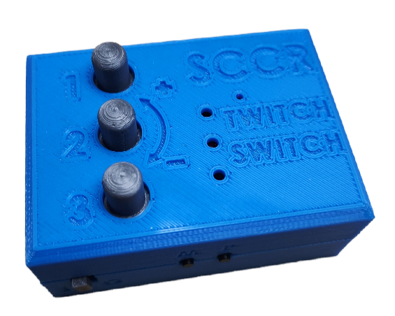

**Twitch Switch Controller**

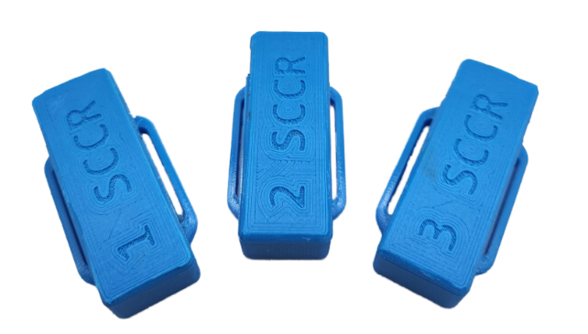

**Twitch Switch Sensor 1**

**Twitch Switch Sensor 2**

**Twitch Switch Sensor 3**

## Controller Features

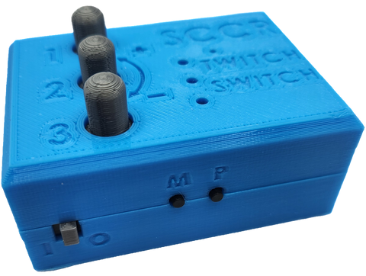

**Indicator Numbers**

**Power Switch**

**Mode Indicator Light**

**Profile Indicator Lights**

**Profile Button**

**Mode Button**

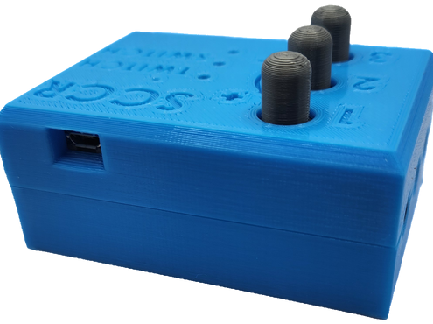

**Micro-USB Port**

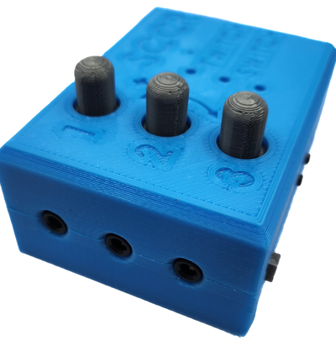

**Manual Calibration Dials**

**Assistive Switch Output Channels**

## Sensor Features

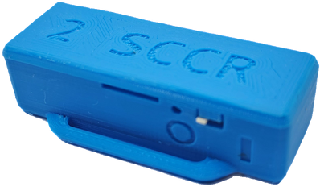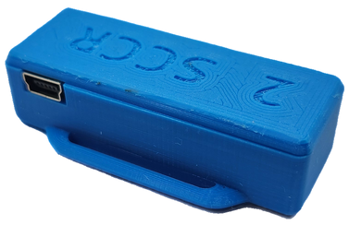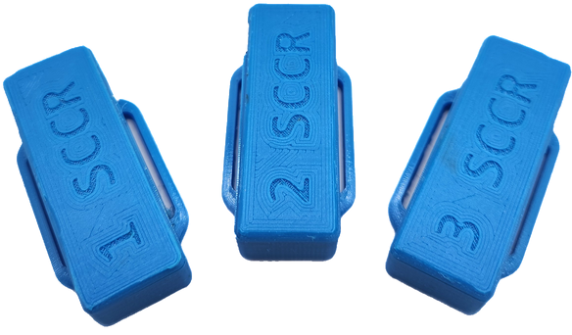

**Indicator Light**

**Power Switch**

**Mini-USB Port**

**Sensor Number**

# Usage

## Compatibility

The Twitch Switch is compatible with Windows and Mac computers, and both Apple and Android mobile devices.

## Sensor Placement

The sensors can be placed on any site where movement can be controlled and repeated. Typical sites are fingers, wrists, feet, and forehead. Suggested materials for securing the sensors include self-adhesive wrap (commonly referred to as ‘Coban®’), headbands, or other soft straps, but you may use any materials you have at your disposal to secure the sensors in place.

The sensors have built-in band loops the keep them secure, as shown below.

Typical placement on finger using self-adhesive wrap:

Typical placement on the wrist or on the forehead:

## Setup Guide

**Step 1:** Place the sensors on the body anywhere movement can be controlled and repeated. See page 7 for sensor placement suggestions.

**Step 2:** Power up the sensors by sliding the power switch to the ON position. When a sensor powers up, the indicator light will blink red 5 times and then remain steady.

**Step 3:** Power-up the controller unit by sliding the power switch to the ON position. The mode light will blink purple intermittently, then will change colour to indicate the mode the device is in (see page 13 for modes). Proceed to the **manual calibration** step if necessary.

If the light does not blink at all, this indicates a low battery. The device will need to be charged before use; please see the charging instructions on page 9.

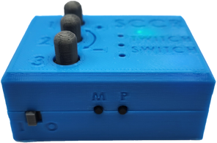

## Charging Instructions

To charge your devices, first locate the appropriate charging cables. You will need a mini-USB cable to charge the sensors and a micro-USB cable to charge the controller.

**Step 1:** Plug the USB cable into a USB wall adapter or other USB outlet such as on your desktop or laptop.

**Step 2:** Connect the appropriate USB cable to the corresponding device. Charging can take up to one hour.

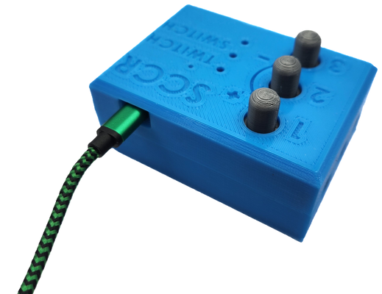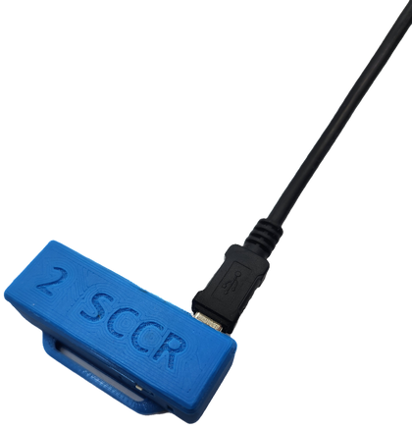

## Manual Calibration

To customize the sensors to the user’s movements, a manual calibration should be performed. This will allow the sensors to detect the user’s movements more accurately without “misfiring”.

To **increase** the sensitivity of a sensor to small or slow movements, turn the corresponding dial counterclockwise. To **reduce** the sensitivity of a sensor, turn the corresponding dial clockwise. Calibration settings are automatically saved to the current profile.

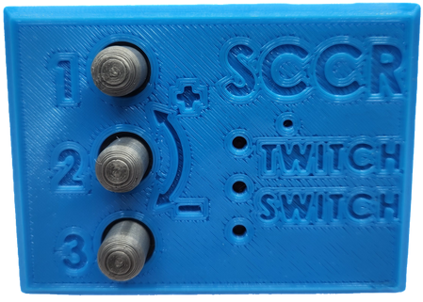

## Controlling Switch Adapted Devices

The Twitch Switch can be used to control switch-adapted devices such as toys, a doorbell, lamp, fan, etc. The Twitch Switch can control up to three adapted devices at one time. It functions by replacing the traditional wired assistive switch, such as a Buddy Button™. Note that your device must already be switch- adapted to be used with the Twitch Switch.

To connect to your adapted device, you will need up to three male to male audio cables. Connect one end to the desired channel on the Twitch Switch and the other in the adapted device. **Note:** the number above the channel indicates the sensor that controls it.

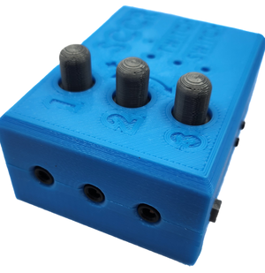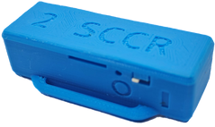

Here is a photo of the Twitch Switch being used to controller a switch adapted toy:

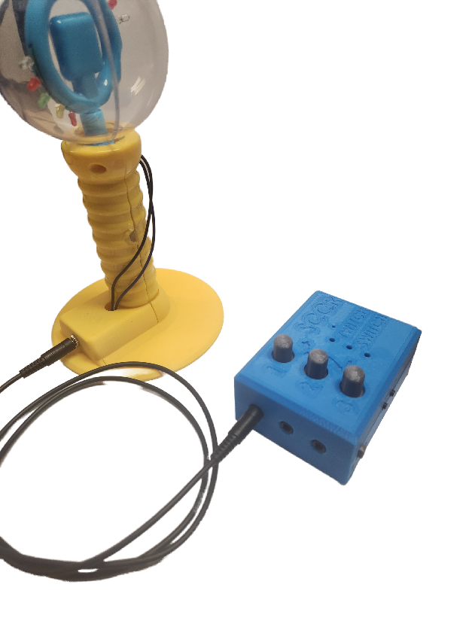

Below are some examples of other adapted devices that can be used with the Twitch Switch. The Xbox Adaptive Controller® can be used with several gaming systems, such as the Xbox One and Windows 10/11 PCs. The adapted media remote may be used to change channels or adjust the volume on a TV. The Twitch Switch can control up to three of functions on either of these controllers.

## Connecting to Computer, Tablet, or Smart Phone

There are two ways you can connect the Twitch Switch to a digital device such as a computer, tablet, or smart phone; either via Bluetooth or through a wired connection.

### Connecting to Digital Device Using Bluetooth

To pair the Twitch Switch with your computer, tablet, or smart phone via Bluetooth, simply locate the Bluetooth Settings of your device. The Twitch Switch is always in “pairing” mode and should automatically appear in this menu as an available device. Select the Twitch Switch and pairing will occur.

If the Twitch Switch is unable to pair, ensure you don’t already have it connected to another device. If so, go into the devices settings and remove or disconnect the Twitch Switch, before attempting to connect to a new device.

### Connecting to Digital Device Through USB

You may also connect the Twitch Switch to your computer, tablet, or smart phone using a micro-USB cable along with an adapter specific to your device, if necessary.

If using an Apple™ product, you will need to connect your micro-USB cord to the appropriate USB adapter for the Lift Switch to function properly as a mouse click device. Some potential adapters are pictured below:

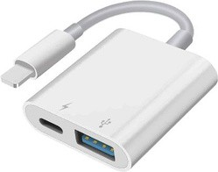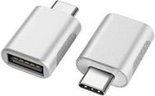

If you are using an Apple™ device, refer to the online instructions found here: https://support.apple.com/en-us/HT211008 for mouse functions, and   
https://support.apple.com/en-ca/HT201370 for Switch Control functions.

## Operating Modes

### Overview

When connecting to a computer, tablet, or smart phone, there are three different modes that can be used, described in the table below. To change the operating mode, press the Mode button (marked with an “M”) on the Twitch Switch Controller, the Mode Indicator Light will then change colours to represent the current mode.

|  |  |  |
| --- | --- | --- |
| Operating Mode | Mode Indicator Light Colour | Mode Overview |
| Mouse Mode | Green | Performs mouse movement and mouse left click. |
| Tablet Mode | Blue | Performs mouse left click, scroll down, and scroll up. |
| Keyboard Mode | Yellow | Performs presses of ‘F1’, ‘F2’, and ‘F3’ keys. |

### Mouse Mode

When the Twitch Switch is in Mouse Mode, the mode indicator light will be **green**. This mode allows users to control a mouse cursor using the sensors. Twitching the sensors will cause the following actions:

|  |  |
| --- | --- |
| Sensor Number | Action |
| 1 | Performs mouse left click |
| 2 | Moves cursor left and right |
| 3 | Moves cursor up and down |

Sensor 1 creates a mouse ‘click’. There is a short delay between clicks to prevent accidental double-clicking. If you are using applications that require double-clicking, it is recommended that you change the settings of your computer or tablet to only require a single-click to open an item.

Sensors 2 and 3 move the cursor around the screen. Sensor 2 moves the cursor left and right, while sensor 3 moves the cursor up and down. Activate sensor 2 or 3 once to start the pointer in their associated direction.

While the cursor is moving, activate *any* of the three sensors to stop the cursor. Activate sensor 2 or 3 again to start the cursor moving in the opposite direction. Repeat these steps as necessary.

### Tablet Mode

When the Twitch Switch is in Tablet Mode, the mode indicator light will be **blue**. This mode allows users to navigate apps on a tablet or iPad. Twitching the sensors will cause the following actions:

|  |  |
| --- | --- |
| Sensor Number | Action |
| 1 | Performs mouse left click |
| 2 | Scrolls down on the screen (on a tablet this will act like scrolling up) |
| 3 | Scrolls up on the screen (on a tablet this will act like scrolling down) |

Sensor 1 creates a ‘click’. There is a short delay between clicks to prevent accidental double-clicking. If you are using applications that require double-clicking, it is recommended that you change the settings of your tablet to only require a single-click to open an item.

Sensor 2 scrolls down the screen, while sensor 3 scrolls up the screen. Note that the scroll directions may be reversed when using a tablet instead of a computer.

### Keyboard Mode

When the Twitch Switch is in ‘Keyboard Mode’, the mode indicator light will be **yellow**. This mode allows users to create a more custom experience by **mapping** actions to keys, and is often used for switch control. The sensor outputs are the following:

|  |  |
| --- | --- |
| Sensor Number | Action |
| 1 | Performs keyboard press of ‘F1’ key |
| 2 | Performs keyboard press of ‘F2’ key |
| 3 | Performs keyboard press of ‘F3’ key |

A great application of keyboard mode is Switch Control. Switch Control is an accessibility function found on Apple™ devices that allows the user to navigate their iPad or iPhone with switches such as the Twitch Switch. For more information on Switch Control, see the following information from Apple™:

<https://support.apple.com/en-us/HT201370>

## Profiles

The controller can store your settings for up to three separate profiles. Both your sensors’ calibration settings and mode are saved to the profile. This can reduce how often the user must calibrate their sensors. The following are some examples on how to use multiple profiles.

**Assign profiles to different positions:** Profile 1 calibrated for a seated position, Profile 2 calibrated for laying down.

**Assign profiles to different levels of fatigue:** Profile 1 calibrated for low fatigue, Profile 2 calibrated for higher fatigue, Profile 3 calibrated to highest fatigue. This would allow the user to switch profiles depending on their level of fatigue at a given time.

**Assign profiles to different functions:** Profile 1 calibrated for use as a cursor on a computer or tablet, Profiles 2 and 3 calibrated for use with other accessible devices.

Change the current profile by pressing the Profile button. The profile indicator light will change to indicate the selected profile.

# Troubleshooting

## Troubleshooting Guide

|  |  |  |
| --- | --- | --- |
| Problem | Possible Cause | Solution |
| Twitch Switch not responding to any movement | Sensor(s) or controller are not turned on or not charged | Ensure sensors and controller are turned on and fully charged |
| Sensor(s) and controller are too far apart | Bring sensor(s) and controller closer together |
| Twitch Switch "firing" randomly | Sensitivity of sensor(s) is too high | Perform manual calibration to decrease sensitivity or reset the device |
| Twitch Switch not responding to every movement, only some | Sensitivity of sensor(s) is too low | Perform manual calibration to increase sensitivity or reset the device |
| Sensor(s) and controller are too far apart | Bring sensor(s) and controller closer together |

## Performing a Factory Reset

If the device becomes unresponsive or you are having difficulty calibrating the sensors, you may perform a factory reset to restore the base settings of the device. Note that all stored settings for **all three** profiles will be lost.

**Step 1:** Turn the device off.

**Step 2:** Hold down the Mode and Profile buttons.

**Step 3:** While holding down the buttons, turn the device on.

**Step 4:** The Mode light will blink purple intermittently, then will blink red three times, indicating a factory reset.

# Cleaning and Maintenance

To clean your Twitch Switch controller and sensors, wipe them with a damp cloth or disinfecting wipe.

The Twitch Switch and the sensors are NOT WATERPROOF – DO NOT IMMERSE THEM IN WATER. This would cause permanent damage to the devices.

Ensure device and sensors are powered OFF after each use to maintain battery life. Charge devices between uses of over one hour.

# Specifications

**Controller:**

|  |  |
| --- | --- |
| Dimension | Value |
| Mass | 125 g |
| Height (without knobs) | 3.3 cm |
| Height (with knobs) | 4.5 cm |
| Length | 8.1 cm |
| Width | 6.0 cm |

**Sensors:**

|  |  |
| --- | --- |
| Dimension | Value |
| Mass | 15 g |
| Height | 1.5 cm |
| Length | 5.1 cm |
| Width (without strap loops) | 1.9 cm |
| Width (with strap loops) | 2.6 cm |